

Drug sting blunder put 100,000 doses on streets
Les Kennedy
September 4, 2008 - 2:36PM
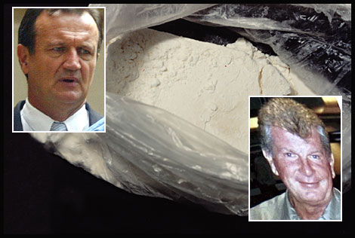
Crime Commission head Phil Bradley approved the operation, in which the drugs came from underworld figure Michael Hurley.
A police drug sting operation, in which six kilograms of cocaine - up to 100,000 doses - was released into the community and never recovered, should not have been conducted by the NSW Crime Commission, the High Court of Australia ruled today.
The drug "sting" operation in late 2004, code-named Mocca, was led by disgraced senior Crime Commission investigator Mark Standen, who is facing unrelated charges of conspiring to import more than 400 kilograms of chemicals used to make the drug "ice".
The High Court's full bench - Justices Michael Kirby, Kenneth Hayne, Dyson Heydon, Susan Crennan and Susan Kiefel - found unanimously today that the operation to release six kilograms of cocaine in a "controlled operation" to drug dealers on Sydney streets was "conduct likely to seriously endanger the health or safety" of users and the community.
The High Court said that, in early 2005, Crime Commission head Phil Bradley approved the operation and that Standen, then an assistant director, authorised an informant - code-named Tom - to sell six kilograms of cocaine to alleged drug dealers in exchange for immunity from prosecution.
The drugs were from 10 kilograms imported into Australia in October 2004 by a drug syndicate headed by the late underworld figure Michael Hurley, who used corrupt Qantas baggage handlers at Sydney Airport.
Tom had worked for the Hurley drug syndicate but was arrested by the commission after selling three kilograms of the imported cocaine and burying the rest in bushland near Wahroonga.
The High Court said the controlled operation led to the arrest of four men who allegedly bought the cocaine from Tom.
But none of the drugs were recovered and NSW Police and the Crime Commission accepted they would never be found.
Two of the men arrested were Gilbert Gedeon, 29, a Parramatta cafe proprietor, and David Darley Dowe, 71, of Coogee.
It was alleged that Tom had supplied three kilograms of cocaine to Gedeon and one kilogram to Dowe.
Both men unsuccessfully challenged the validity of the operation to the NSW Court of Criminal Appeal after Dowe was sentenced to 12 years in prison in November last year.
Gedeon's trial is still pending.
Last month both men were granted leave to appeal to the High Court.
Their lawyers argued the controlled operation was unlawful and should be declared inadmissible as evidence at trial because the drugs could have harmed members of the public who bought them.
They also submitted that, because the commission had failed to obtain authorisation for the operation from federal authorities, the operation was invalid.
In its unanimous judgment today the High Court said: "Controlled operations that involved the selling of large quantities of cocaine to users was conduct likely to seriously endanger the health or safety of those people and should not have been authorised by the NSW Crime Commission."
The High Court ordered the Crime Commission to pay the two men's legal costs.
It said the Crime Commission had no "no statutory power to grant an authority" for such an operation.
"The commission had estimated that the conduct of the controlled operations using Tom was that between 70,000 and 100,000 dosage units of cocaine would reach the streets," the High Court said.
"The Court held that a reasonable person in the position of the commissioner would have foreseen that this would involve a risk of seriously endangering the health of at least some of the purchasers of the cocaine. It held that that prospect was sufficient to attract the prohibition in section 7(1)(b) (of such an operation)."
This story was found at: http://www.smh.com.au/articles/2008/09/04/1220121404203.html

