Cops' botched cocaine sting slammed
Article from:
By Janet Fife-Yeomans
September 05, 2008 12:00am
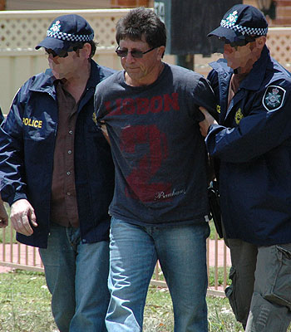
Jailed ... Les Mara.
THE investigation into cocaine smuggling involving baggage handlers at Sydney airport ended yesterday in disgrace for the NSW Crime Commission and the state's police.
Operation Mocha, which allowed 7kg of cocaine worth more than $1 million to be sold on Sydney streets to infiltrate a drug syndicate, was slammed by the High Court.
The botched operation, which failed to recover 6kg of the drug, was approved by the head of the NSW Crime Commission Phil Bradley, at a meeting attended by current Police Commissioner Andrew Scipione and his predecessor Ken Moroney.
It should never have been sanctioned, said the court in a scathing judgment.
The High Court said Mr Bradley would have foreseen that selling cocaine would, "involve a risk of seriously endangering the health of some at least" of the drug users.
By declaring the approval to sell the cocaine invalid, the High Court has cast doubt over convictions secured by the operation, defence experts said.
Eleven men were originally charged, three with conspiracy to import cocaine and the others with supplying the drug in Sydney.
The kingpin Michael Hurley, died last year in jail while awaiting trial. Former rugby league player Les Mara pleaded guilty to conspiracy and was jailed for a minimum of 13 years. Shayne Hatfield also pleaded guilty to the conspiracy and is awaiting sentence.
The High Court challenge was mounted by Gilbert Gedeon, who is awaiting trial charged with supplying cocaine, and David Dowe, who is appealing his conviction and 12 years' jail sentence for supplying the drug.

